Marnie Custom Homes
HydroGap SA Installation Instructions



Tools Needed: Measuring tape, chalk line, box cutter, push broom, stapler, caulk tube gun or sausage gun, hand applicators.
- Optional tools: Top sheet cutter, cap stapler, small hand brush, squeegee.
Important notes to keep in mind.
- 4” overlaps on the horizontal seams, 6” on the vertical seams, 12” on the corners
- This product and the flashing tapes are Pressure Activated so they need to be installed by applying pressure with applicator, brush, or squeegee.
- Don’t adhere the top window detail to the substrate until the window is set, flashed, and particularly that the header flashing is installed directly to sheathing.
  - Cut a relief cut, 45° away from top corners approximately 6”, in the wrap and use some release liner to protect the adhesive
    - Make sure shiny side is OUT

Prep the substrate by cleaning off any dirt, dust, or debris.
  - Make sure it is dry to the touch as well

Corner Wrap Detail:
- Using a hack saw, cut a roll of HydroGap SA into a 2’ section
- Start at the top of the structure and drop the short roll to the bottom of the structure.
  - Or start at the bottom and work your way up
  - Peel the release liner and adhere to the substrate.
  - Grab your push broom and apply even pressure to the wrap
Wrap Install Detail:
- Start at the bottom of the structure and chalk a line of the width of the roll (57 inches or 4.75’) with the logo facing upright.
  - Make sure the wrap goes onto the substrate with 2” overlapping onto the foundation
- Peel the top release liner and line up with the line. Put the material onto the substrate
- Peel the bottom release liner and attach to the substrate
- Continue up the wall until you terminate at the roof line following the overlapping specs
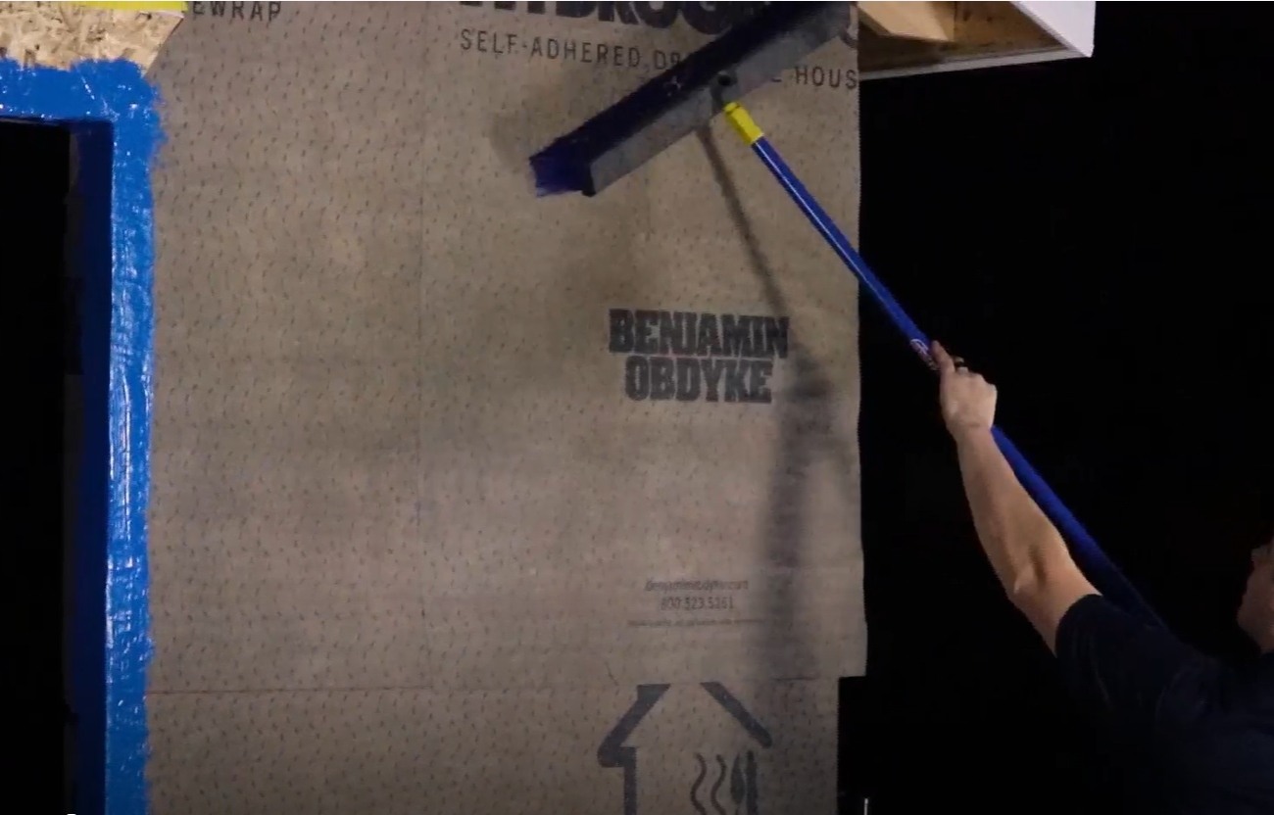

For The Windows:
If the windows are installed AFTER the wrap follow the below:
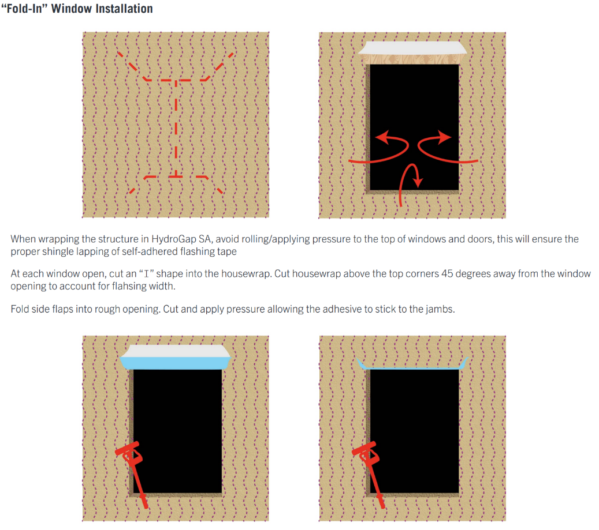

- Where the wrap covers the windows follow the “I” method below
  - Cut wrap horizontally in line with top of window rough opening
  - Starting 4” below the top of the window make a vertical cut towards the bottom. Stopping 4” above the bottom sill
  - Make a 45 degree cut towards each corner of the sill from the bottom of the window
  - Fold in all the window sections and apply pressure to adhere the wrap.
    - Leaving the top part NOT ADHERED yet, use the release liner to prevent it sticking to sheathing.

- Take a strip of 4” HydroFlash GP tape and run a starter strip the length of
the window past 2” of each side of the window.
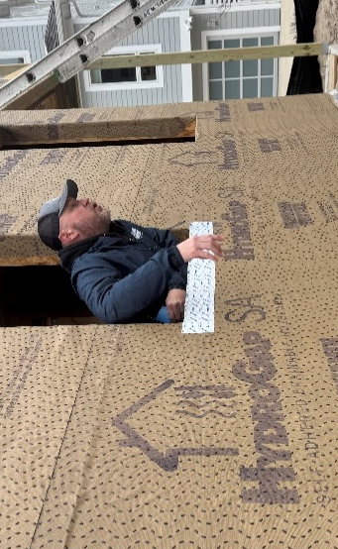
- Apply the blue Hydrocorners to the bottom of the window in the corners
  - Make sure to apply a bead of the HydroFlash LA (blue stuff / blue goo) to the face of each of the rough opening corners
  - Tack in place with one staple
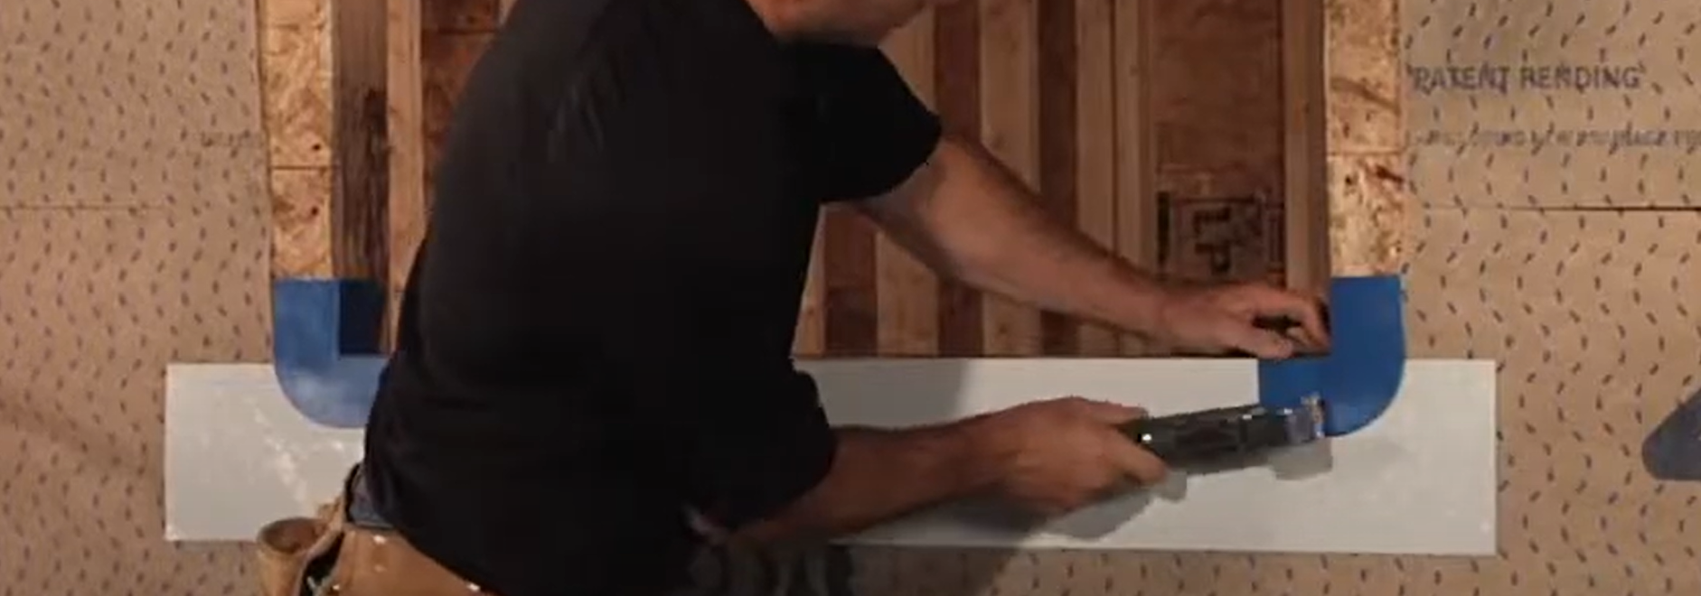
- Cut a strip of the 9” Hydroflash GP tape extending up a minimum of 6” of the rough opening jambs
  - Make a relief cut in each corner so tape can be wrapped onto outer face of corners (careful not to cut too much)
  - Apply enough pressure to the tape to see and feel the bumps through the tape
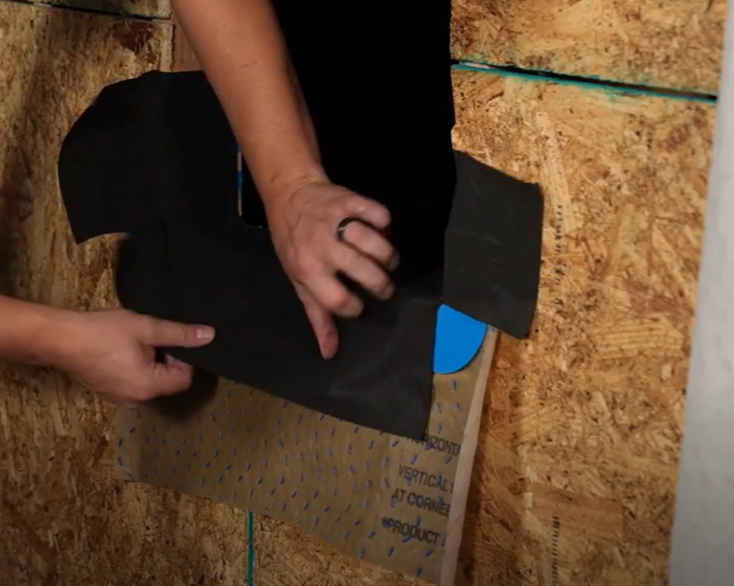

- Apply Hydroflash LA to the back of the window fin, jambs and header only, leave the sill open/unsealed.
  - Set window and start to drive the nails
  - Make sure there is blue material showing from all elevations
  - 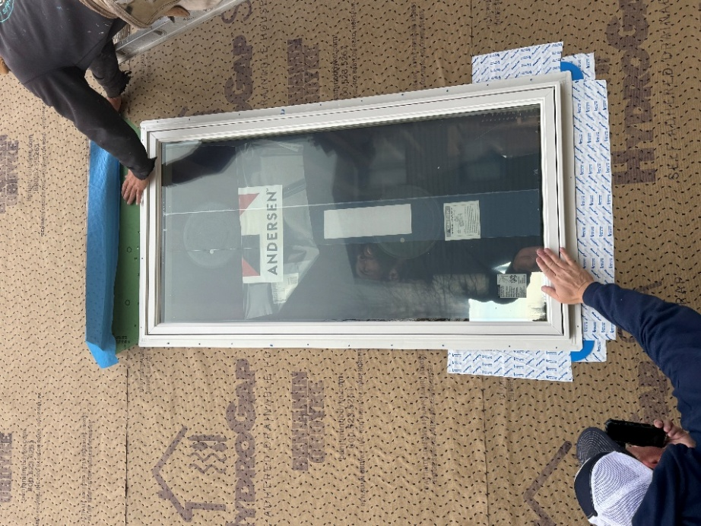
- Cut 4” HydroFlash GP with lengths starting 2-3” above the top of the window to the at least 4” below the sill
Trouble Shooting Tips
If you cannot see / feel the spacers through the flashing tape have them apply pressure to the tape
If HydroGap SA has not been properly adhered / is pulling away in an area
- Put a couple cap fasteners in the area to tack it in place and re-apply pressure to the wrap with your push broom
If you have tears in the wrap / need to patch an area
- Use Liquid Applied (Blue goo), tooling/smoothing it out, on the area OR
- Cut a piece of flashing tape and turn it so it looks like a diamond

***Please refer to our standard install guide for any details not covered here or Call Mike Lee from Benjamin Obdyke with any questions (308) 325 – 9738 or mlee@obdyke.com ***

