
Jobsite Compliance Violation Notification
Subcontractor Safety Violation Notification

PROJECT INFORMATION
Project Name: | Address:
Date: | Time:
INDIVIDUAL OR COMPANY INFORMATION
Company Name:
Type of Warning: Verbal Written Dismissal
Supervisor Responsible:
Office Contact Number:
DESCRIPTION OF VIOLATION
Safety Quality/Workmanship Code Compliance Cleanliness/Jobsite Organization Damage to Property
Schedule/Delays Conduct/Behavior Unauthorized Work Other
Describe unsafe act or conditions below:
CORRECTIVE ACTION

Please describe corrective action taken below:

Unless otherwise noted, all violations must be corrected within 24 hours. Above, state the corrective action you have taken and return the information to the Site Superintendent and/or Site Representative. In the event that the subcontractor field supervisor does not produce satisfactory results, we will contact the subcontractor’s main office and request immediate repair.

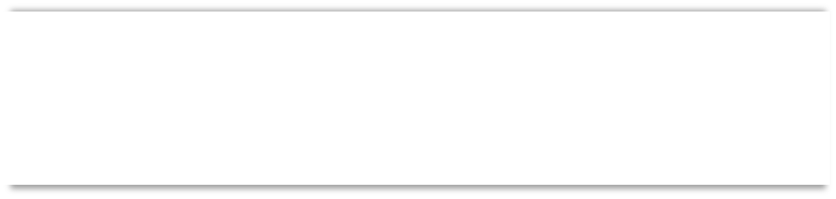

Should both notifications fail to correct the situation, we reserve the right to remove any employee(s) involved with the subcontractor until all parties involved have reached an agreement. This practice is in accordance with our standard contract for subcontractors.

DUSTIN BURKETT, DIRECTOR OF CONSTRUCTION

Signature: Date:
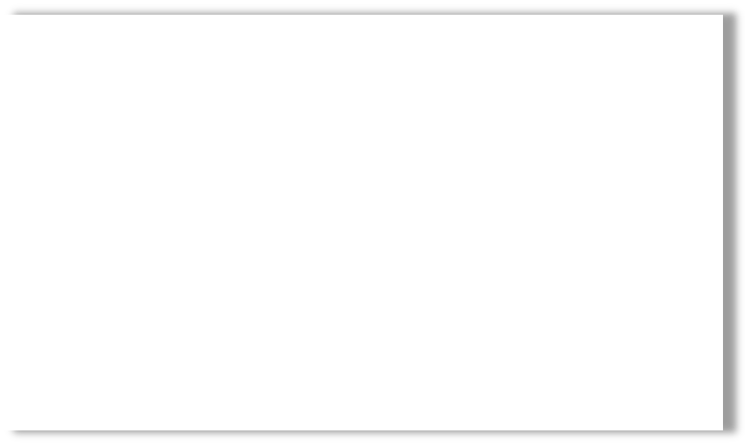
1st Warning 2nd Warning
3rd Warning: $250 Fine
4th Warning: $500 Fine 5th Warning: $1,000 Fine

